
SIT102 Test 2 (Practice) - 2026 T1

Student Name: Saloni Mehta

Student ID: 223456
O cial Use

⃝ Complete ⃝ Fix and resubmit ⃝ Redo

The following struct and procedure are de ned.
const int SIZE = 5;
struct stat_double
{
double numbers[SIZE]; double mystery;
};
void who_am_i(stat_double &data)
{
Int i;
data.mystery = data.numbers[0];
for ( i = 0; i < SIZE ; i ++) {
if ( data . numbers [ i] > data . mystery ) { data . mystery = data . numbers [ i];
}
}
return ;
}

- Hand execute the code below using this procedure.
// Initialise d. numbers with { -20.0 , 3.2 , 1.9 , -1.5 , 1.3}
// and d. mystery with 0.0 ' .
stat_double d = { { -20.0 , 3.2 , 1.9 , -1.5 , 1.3} , 0.0 };
who_am_i ( d );

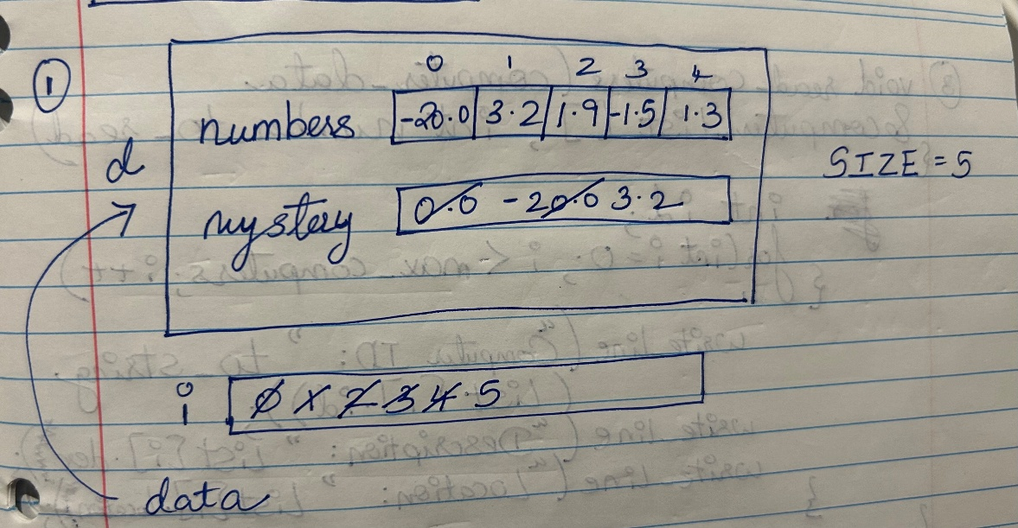

SIT102 Test 2 Trimester 1, 2026

You are creating a system for managing computers in an o ce. The following elds are needed to represent a computer: (1) an identi cation number; (2) a description; (3) a location.
- Write a data structure named computer_data to capture these elds.

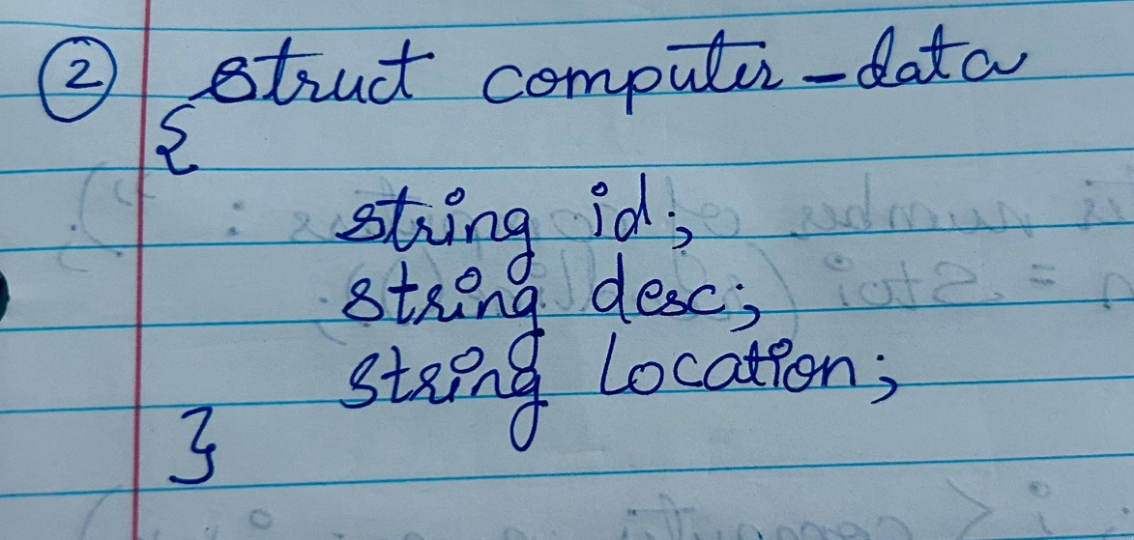

- Write a function to read in the information for a number_to_read number of computers into computer_list.
void read_computers ( computer_data & computer_list [], int number_to_read )

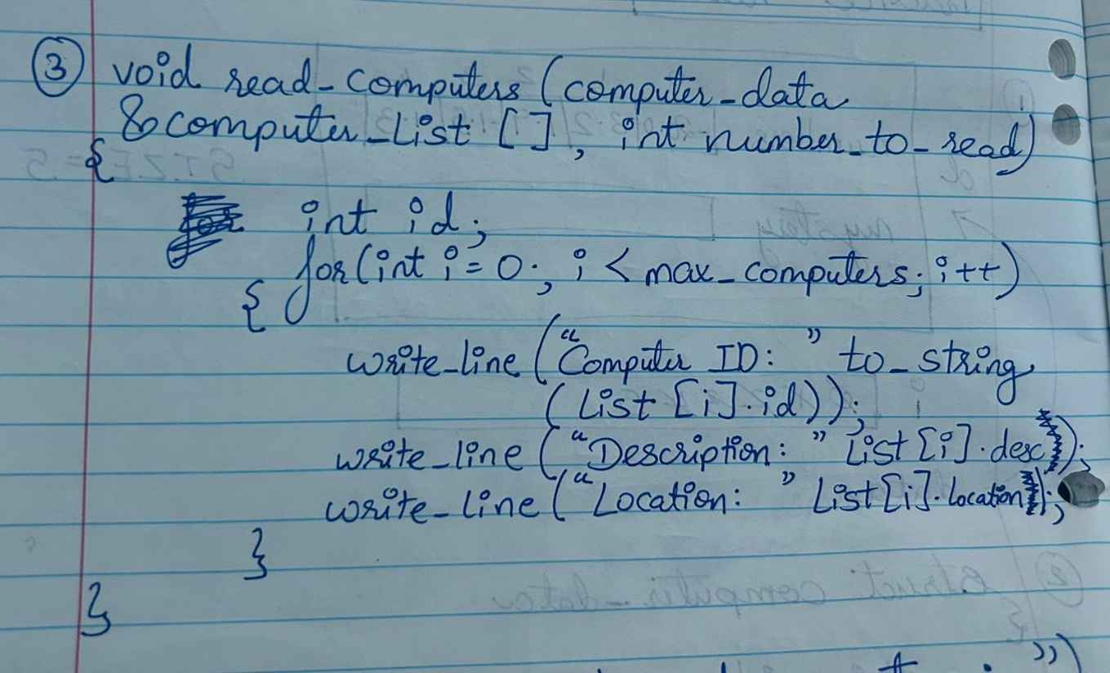

- Write the main function which asks the user for computer_num number of computers. Then call your read_computers function to read in data for computer_num computers. Finally, print the list of computers.
int main ( )
{
const int MAX = 100; // Maximum size of array of computers computer_data computers [ MAX ]; // Array of computers
int computer_num ; // Actual number of computers stored

// Ask for number of computers

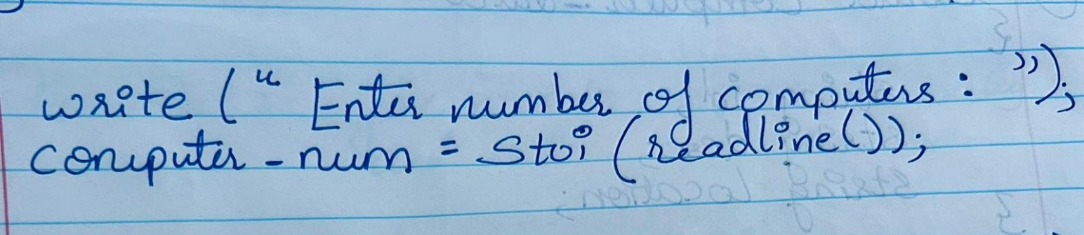

// Read in computer list

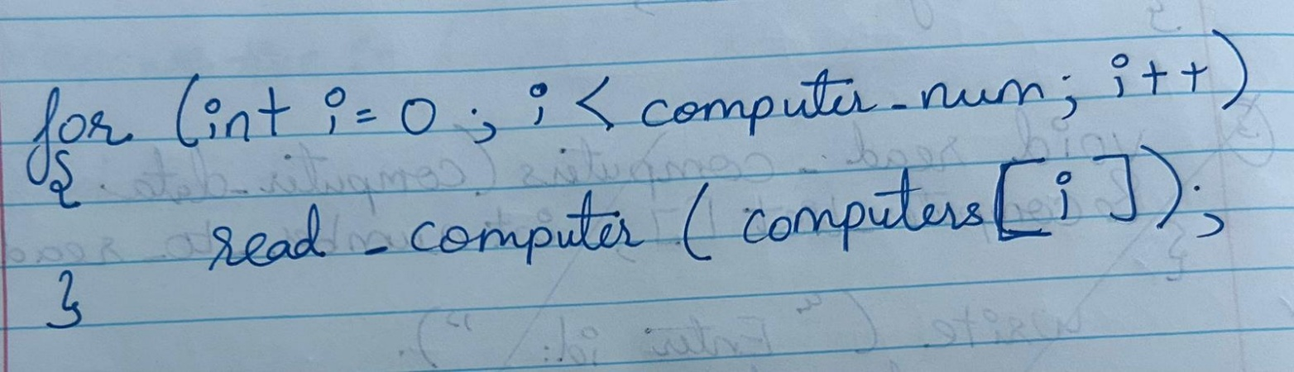

// Print list of computers

